Activity Diagram Perekaman Data Kendaraan

Activity Diagram Log In

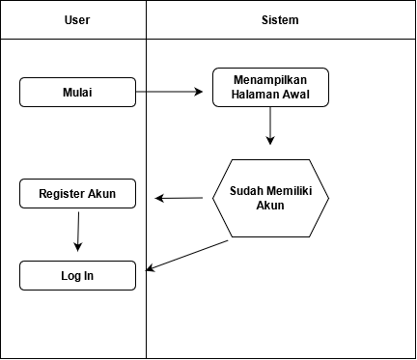

Activity Diagram Tambah Data Kendaraan Keluar

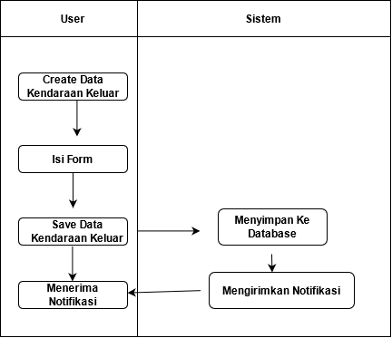

Activity Diagram Membaca Data Kendaraan

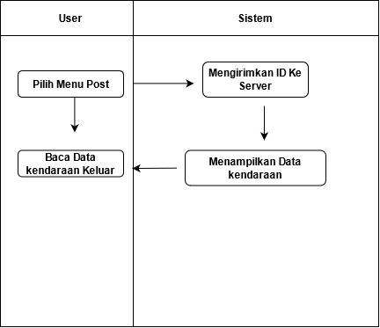

Activity Diagram Edit Data Kendaraan

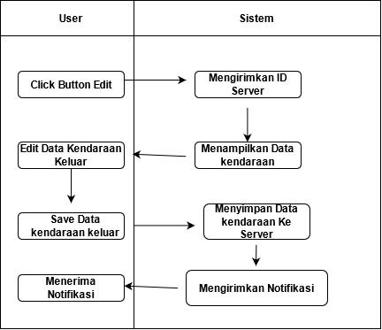

Activity Diagram Hapus

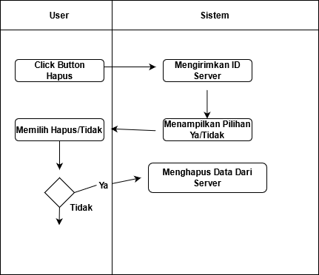

Activity Diagram Log Out

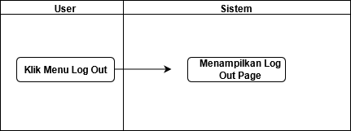

**PENJELESAN**

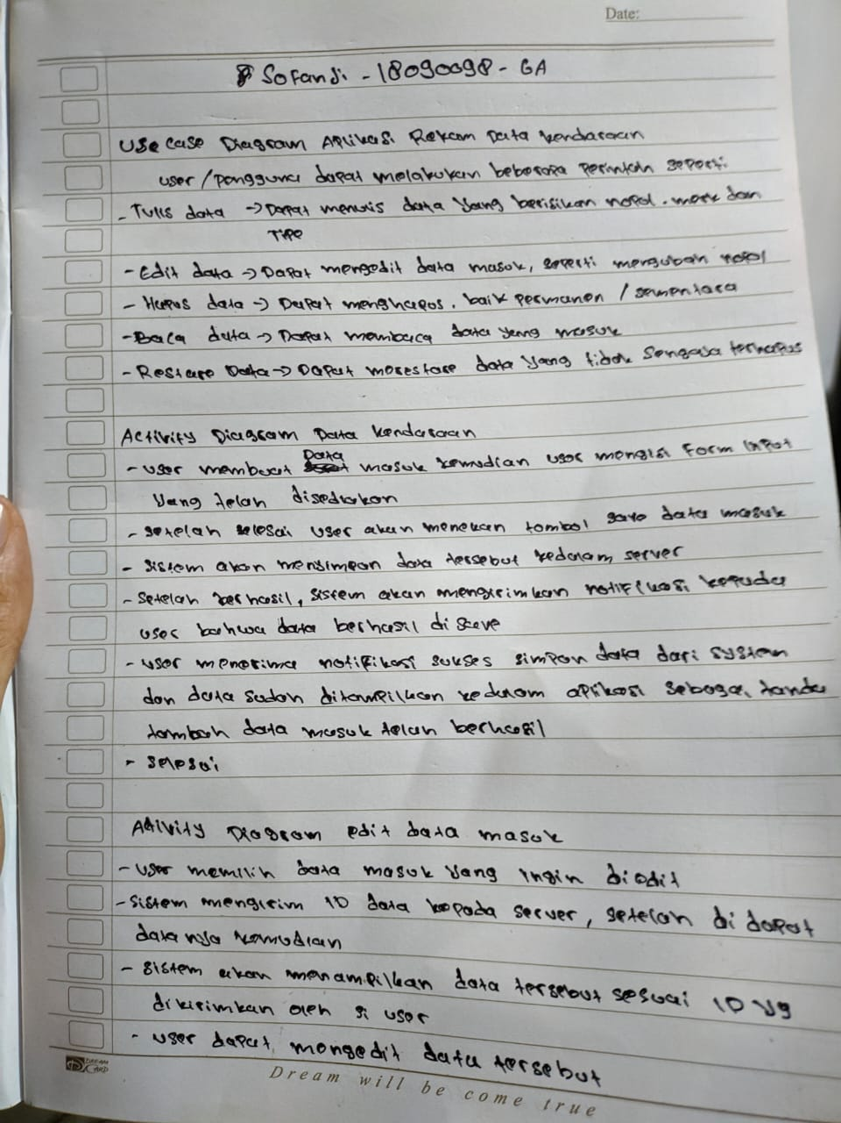

**PENJELESAN**

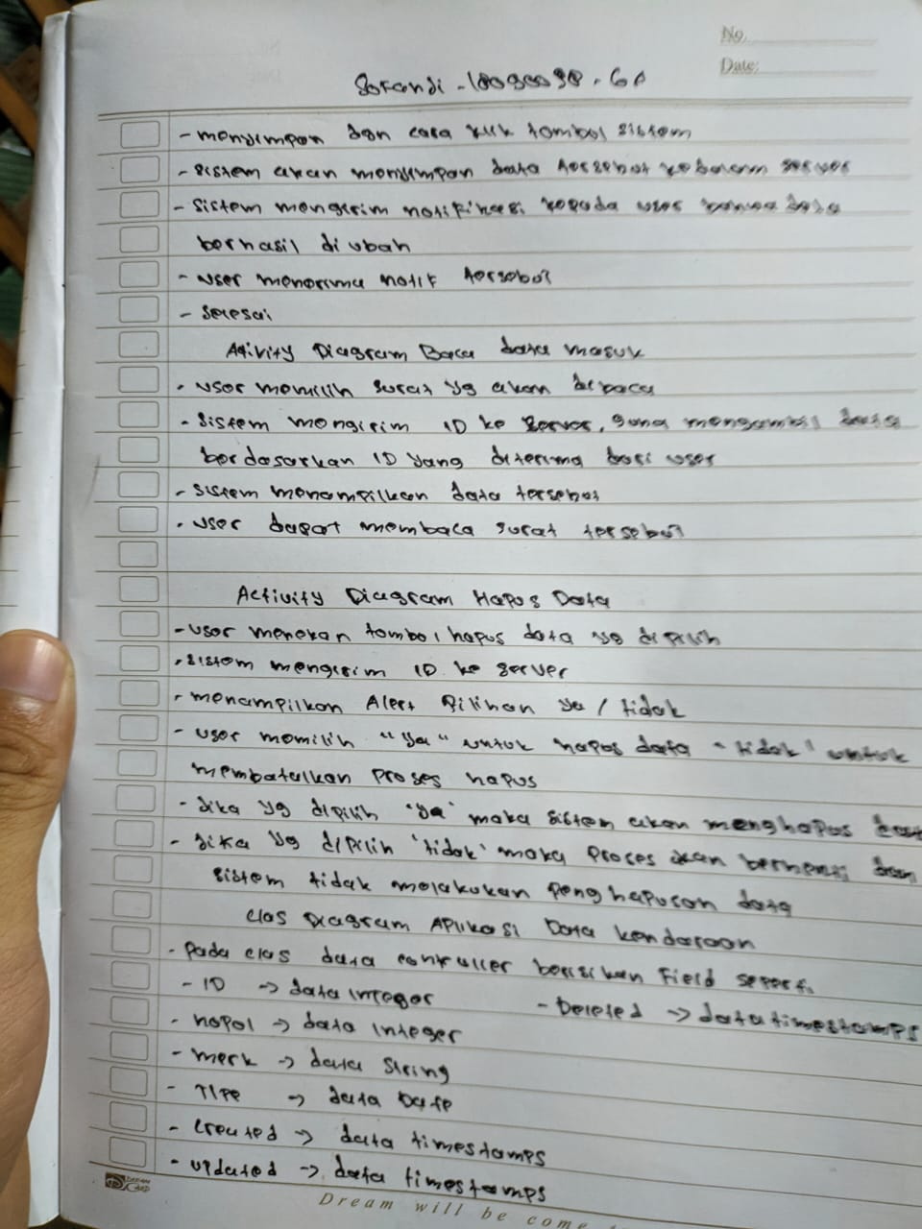

**PENJELESAN**

